**DEMO for POM Automation**

Contents

**Import project** 1

**DEMO TESTCASE “empty_contact_10”** 3

**In testcaseData file :** 3

**In data/ .properties :** 3

**In suite :** 3

**In scripts:** 3

**Tips** 5

# **Import project**

**Step#1**: Go to folder \\100.30.8.166\sharing , copy POM312.zip

**Step#2:** Import **POM312** project (maven project)

File -> Import… -> Choose Maven/Existing Maven Projects -> Next ->

* Choose folder POM312 -> Check checkbox pom in **Projects** -> Click Finish

Wait until project is imported completely (about 3minutes).

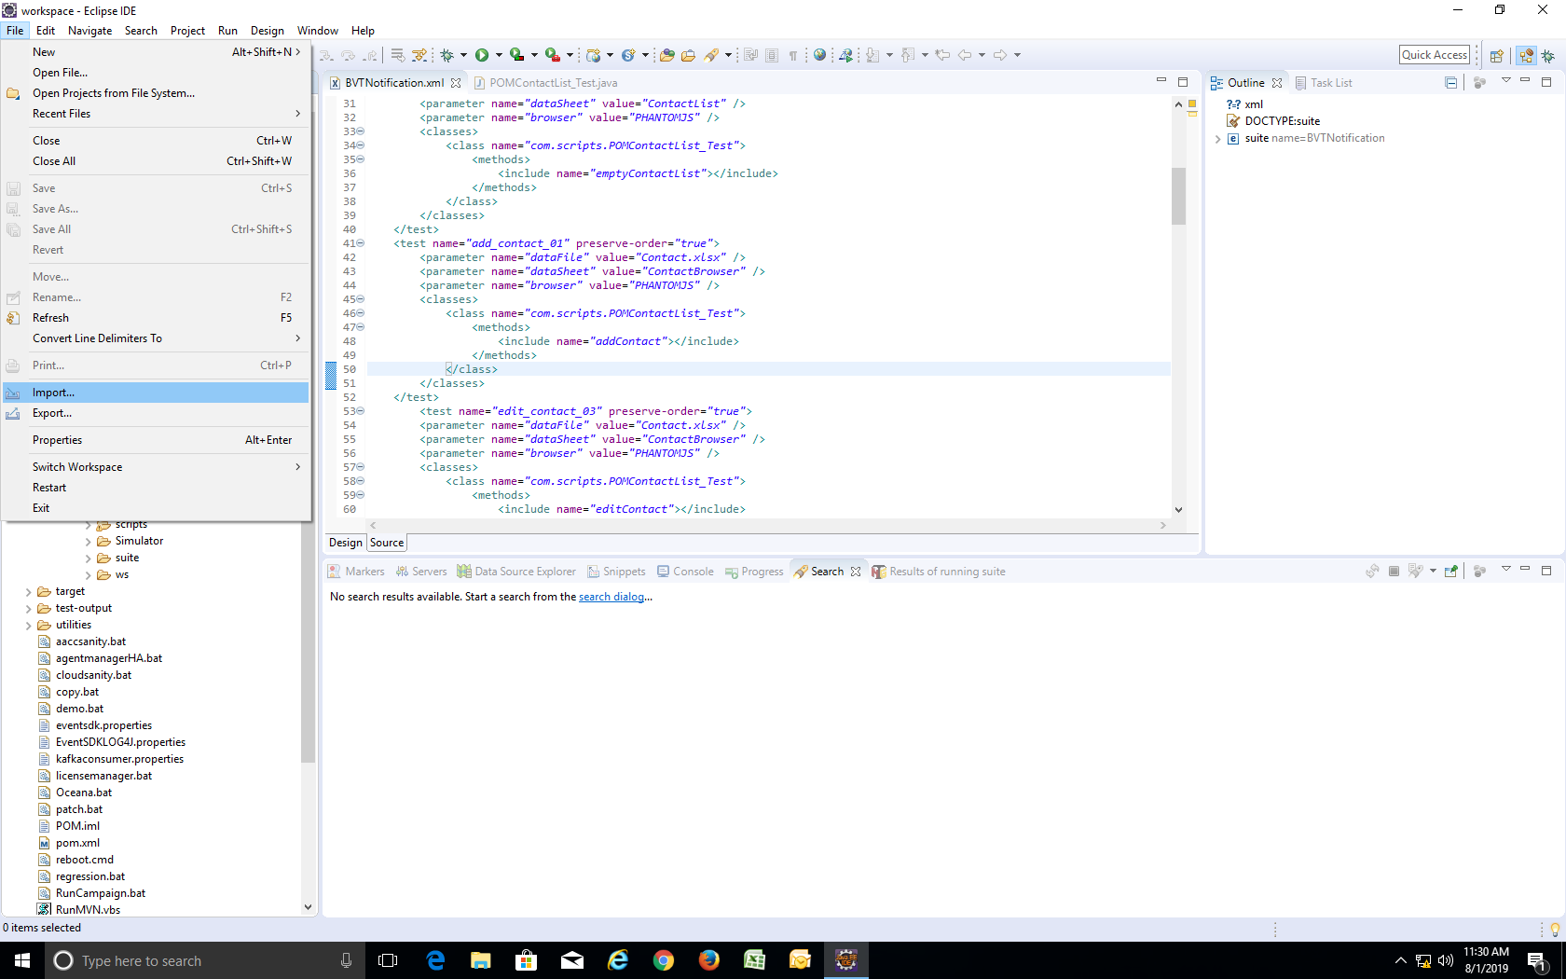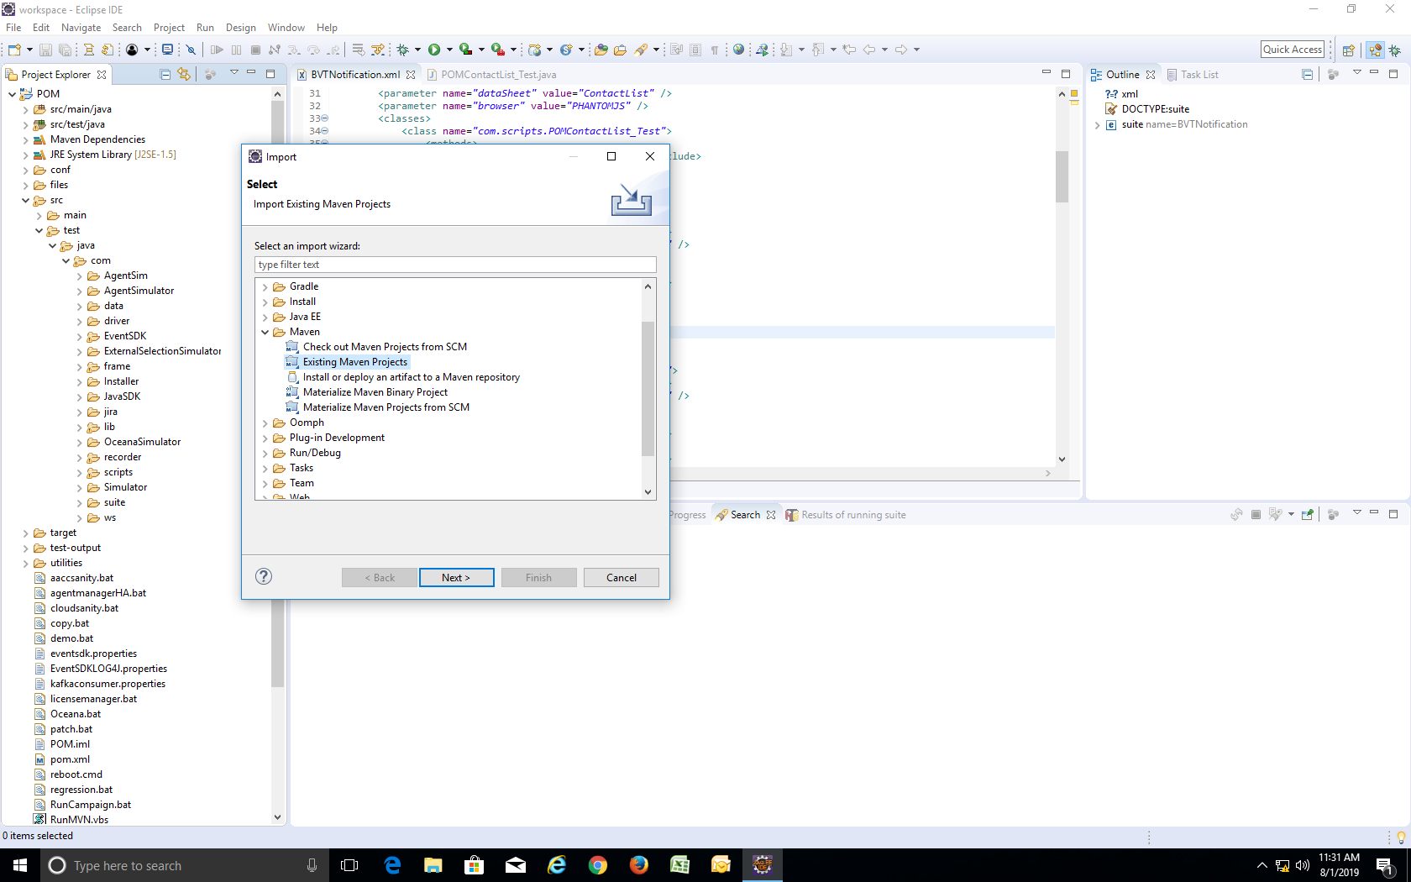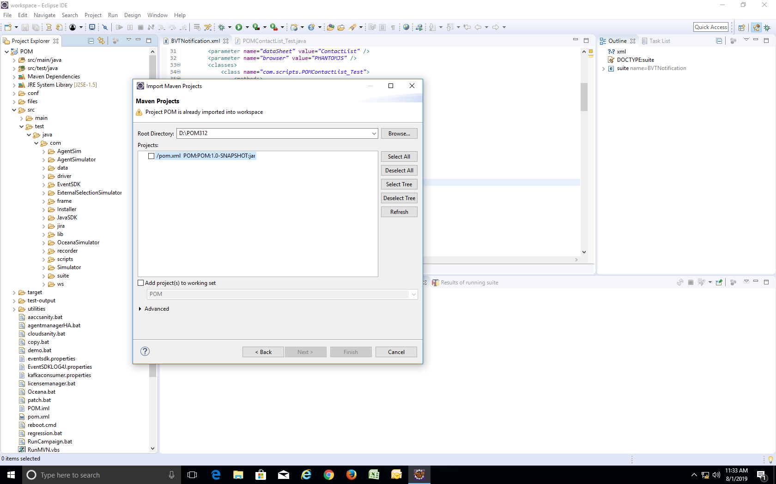

🗹

**Step#3:** add **setting.xml** to **C:\Users\<your_username>\.m2** (for fix proxy error)

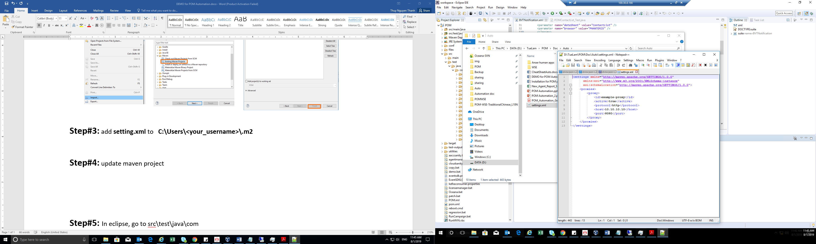

**Step#4:** update maven project in eclipse

Right click on POM project -> Maven -> Update project ->

* Choose project and check checkbox Force Update of Snapshots/Release
* Click OK

Wait until project is updated completely

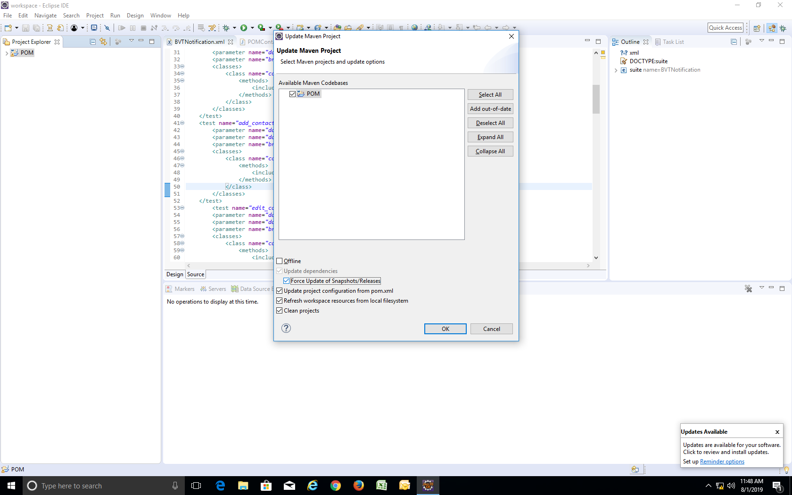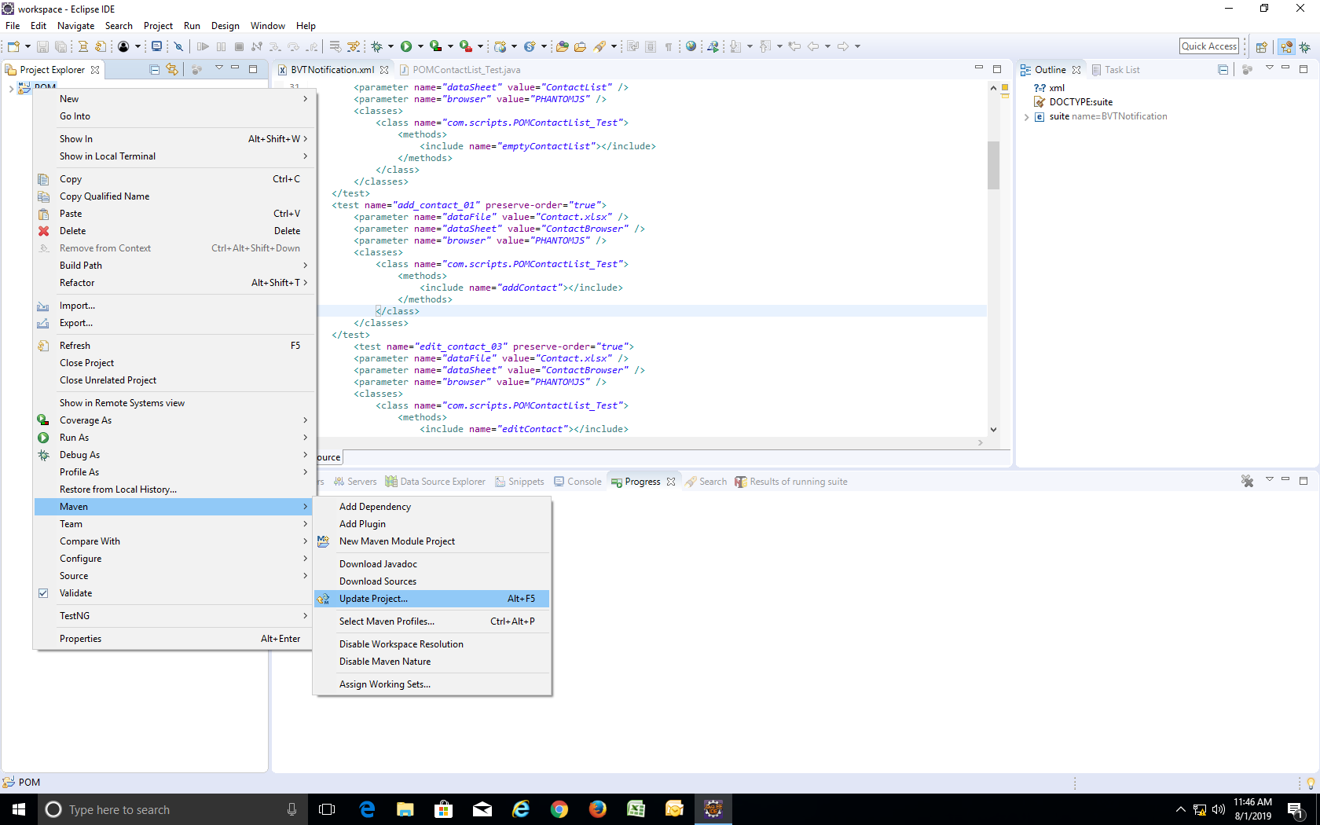

**Step#5:** In eclipse, go to src\test\java\com

**Note : Should self-investigate POM_Automation_Getting_Started.pdf**, 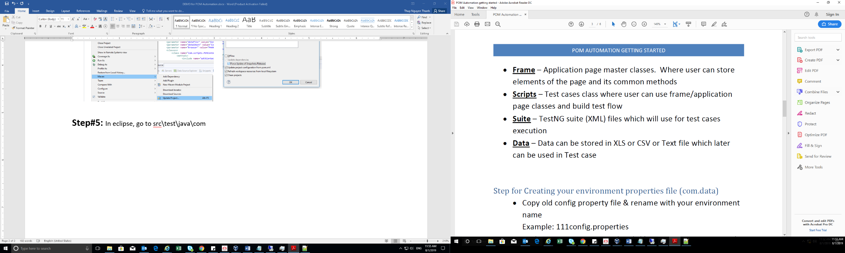there have all steps for create and run test case.

# **DEMO TESTCASE “empty_contact_10”**

* Suite : suite/BVTNotification.xml
* Script : scripts/POMContactList_Test.java
* Method : emptyContactList
* Testcasedata : data/testcasedata/Contact.xlsx , data sheet : ContactBrowser
* Main Frame : frame/POMContactListsPage.java
* Related frames : POMDNCListsPage.java, POMContactAttributePage.java

## **In testcaseData file :**

Contain all data for run test case. May have 1 or more sheet.

Some column is **required** for **all** **testcaseData** **file**: **TestcaseID, TExecute, FEAT, OUTREACH**.

**************************************

## **In data/ .properties :**

You should create **new** **.properties** file with **your system info** following 88config.properties file.

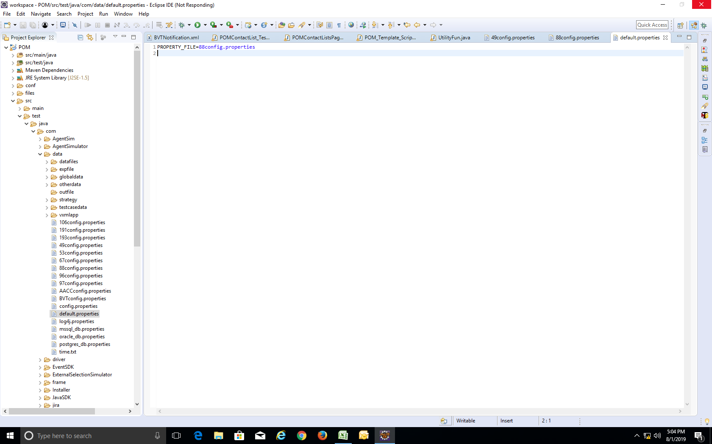 Then fill in default.properties file as below. That file use to define what system is choose to run.

**************************************

## **In suite :**

Use to map testMethod with data file.

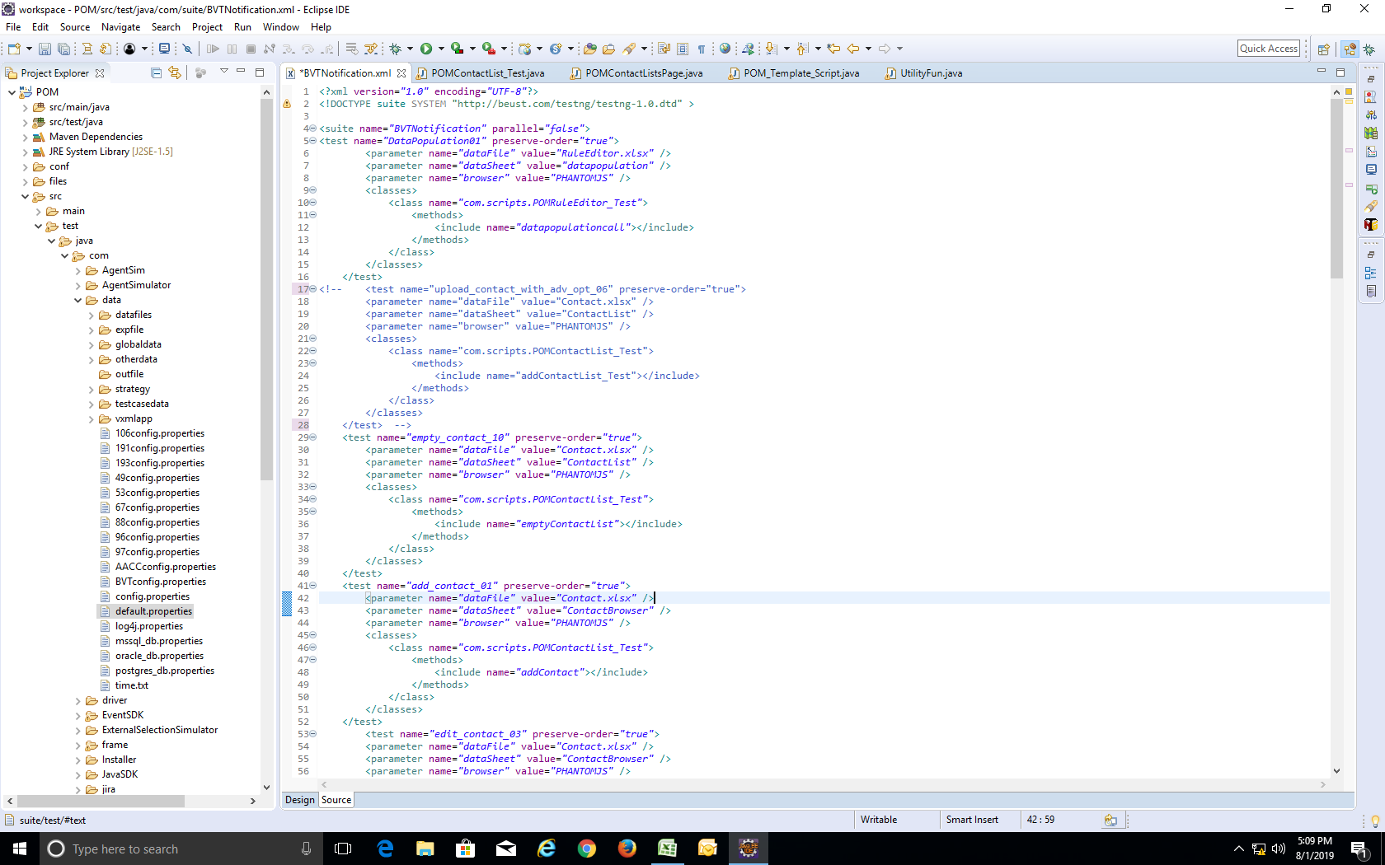

Use “<!-- … -->” to comment code.

That mean this TC will not be run



Test name need be matched with TestID in data file

Class name : name of script

Method : test method (test case)

**************************************

## **In scripts:**

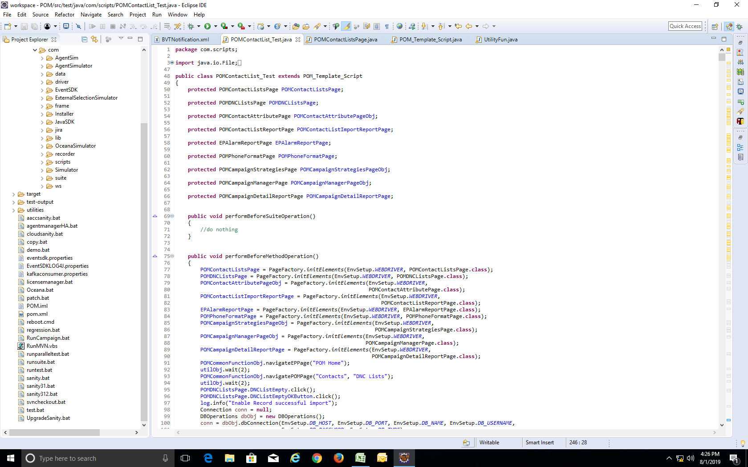

Declare page object

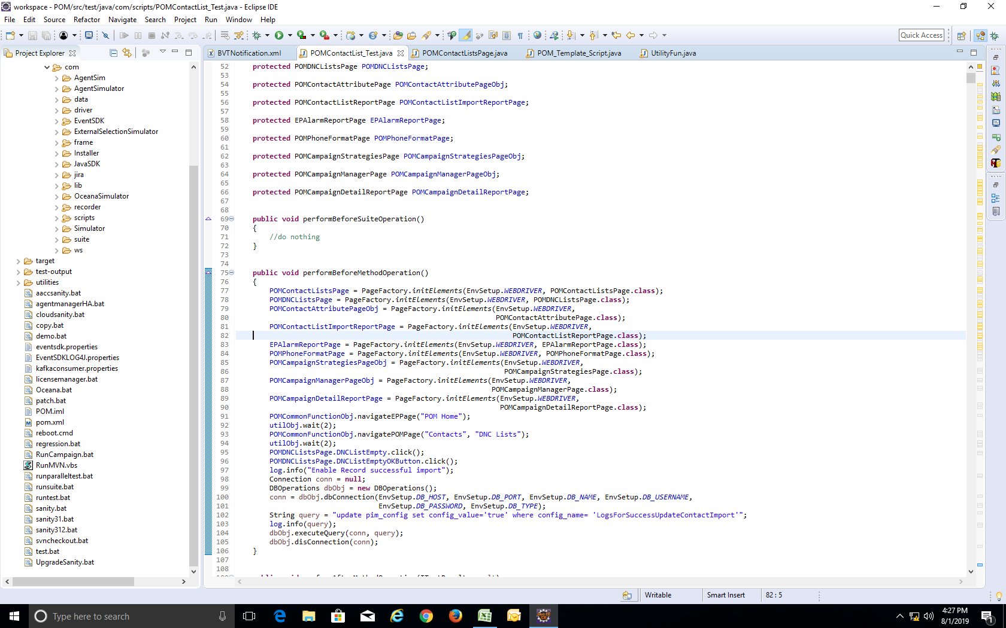

Initial page object

@Test : define a testcase

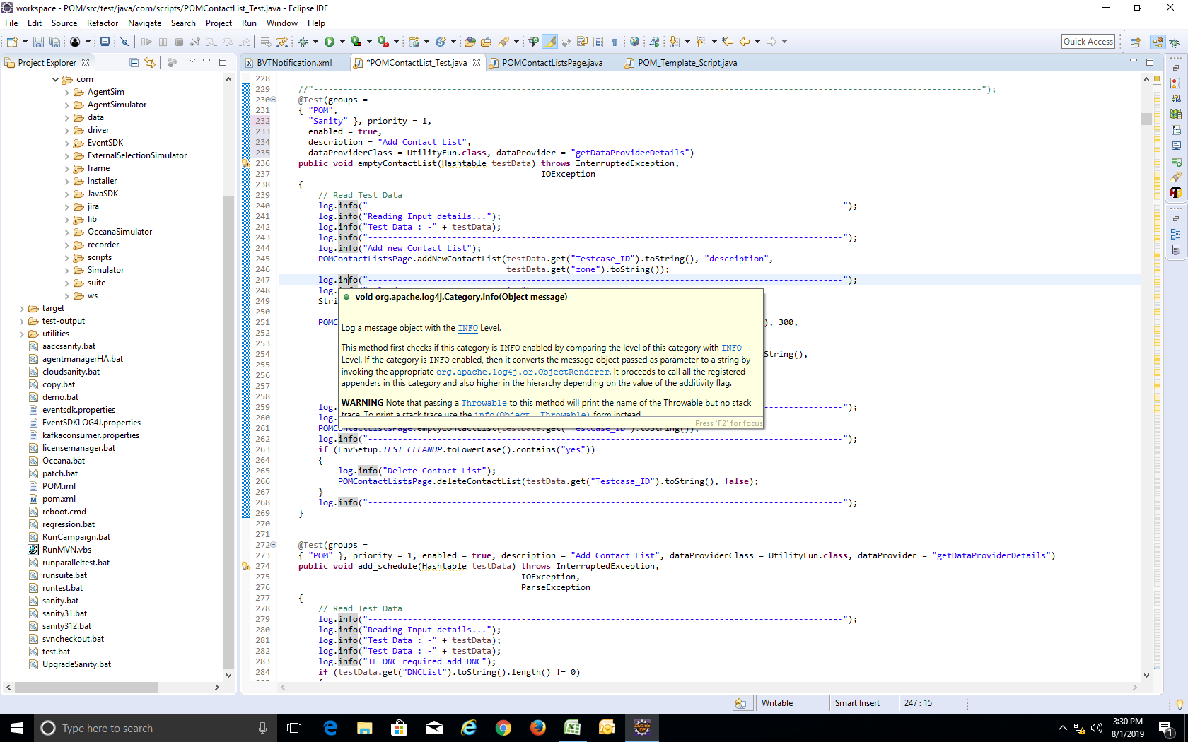

Test method

(test case)

testData : contain all data in testcaseData file

groups : define group what TC belong to

enable : true -> TC can run, false -> TC cannot run although in testcasedata is set as “yes”

dataProviderClass, dataProvider : provide data as Hashtable (should not change 2 parameters)

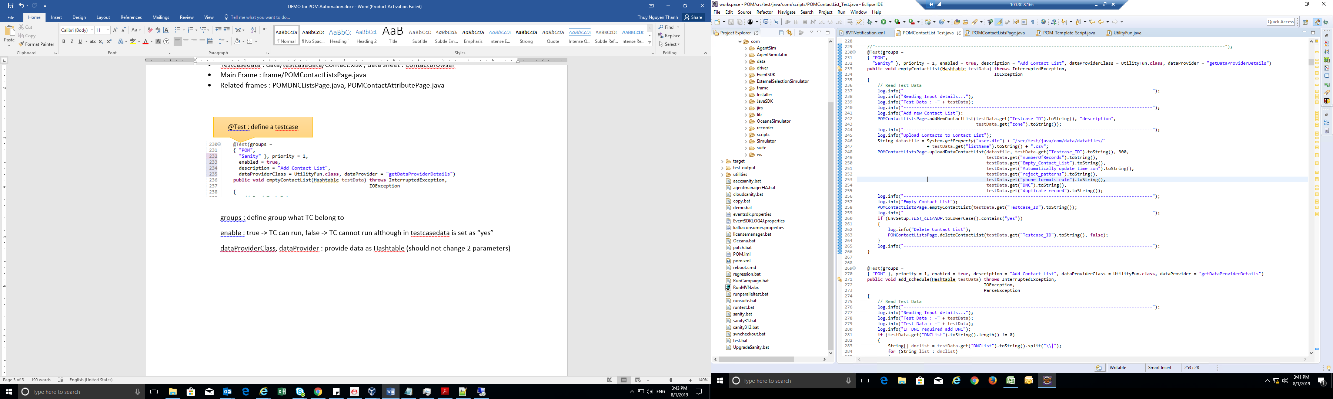

log.info(<info>) : print <info> to log file or Console when run TC

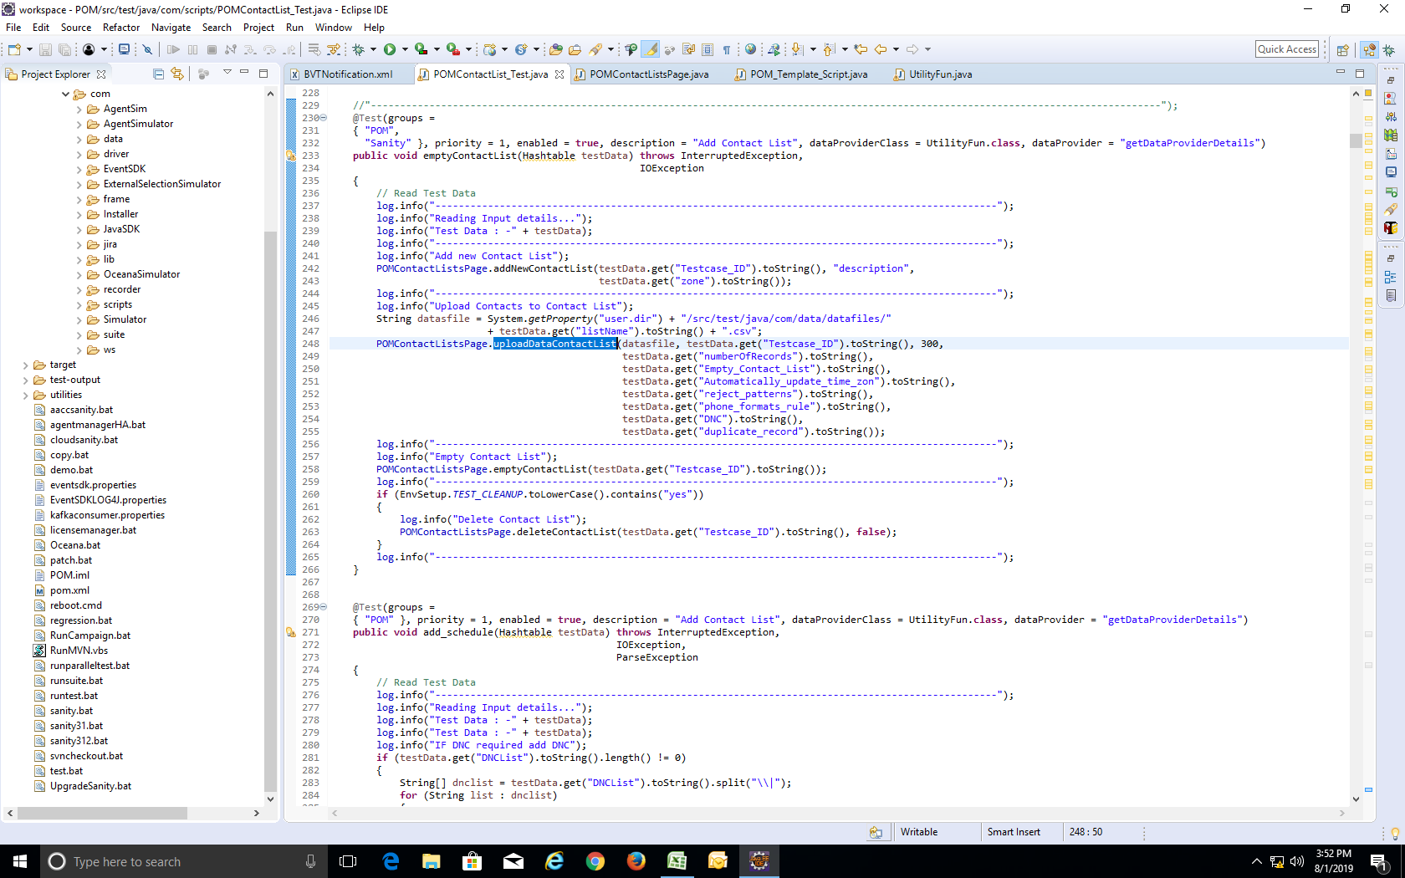

<Page_object>**.**<method>**(**<parameters>**)** :call method from page object

**testData.get(“**<col_name>**”)** :get data of <col_name> column

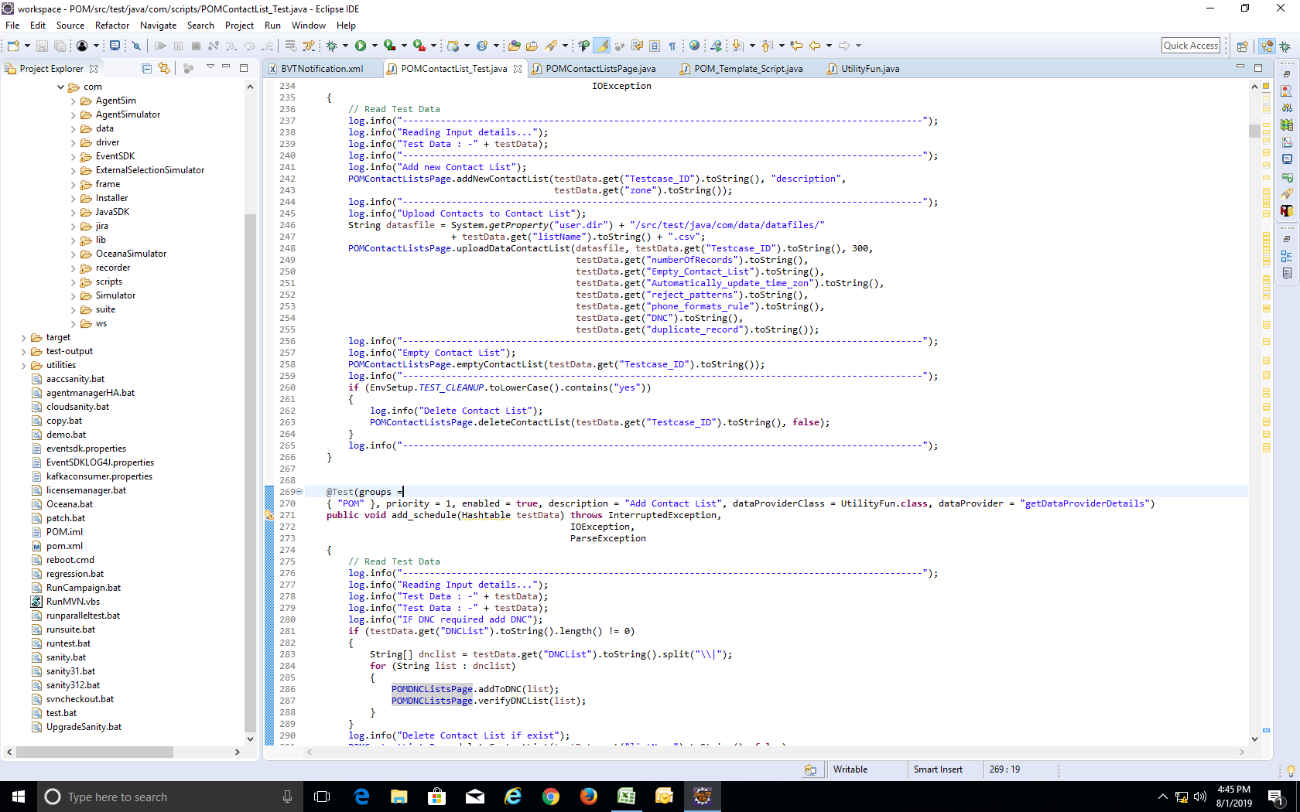

Clean up test case data is turned on when TEST_CLEAN_UP=yes in .properties file

**************************************

# **Tips**

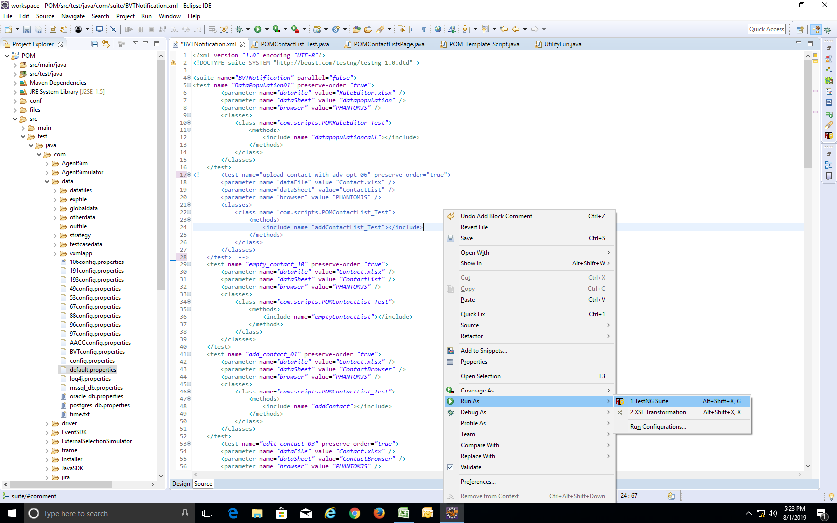**To run a suite** : right click on this suite and choose Run As -> TestNG Suite

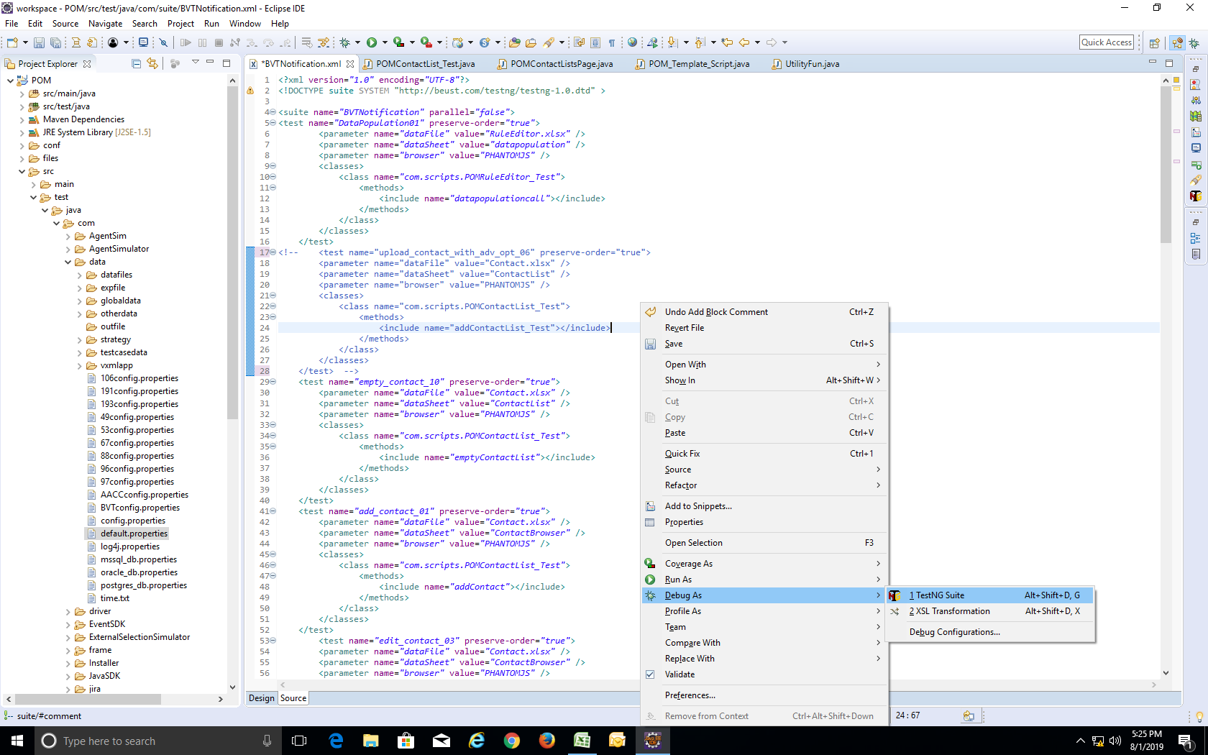**To Debug as suite :** right click on this suite and choose Debug As -> TestNG Suite

**Add breakpoint for debug**  : when run debug, program will stop at breakpoint. Then we can debug easier

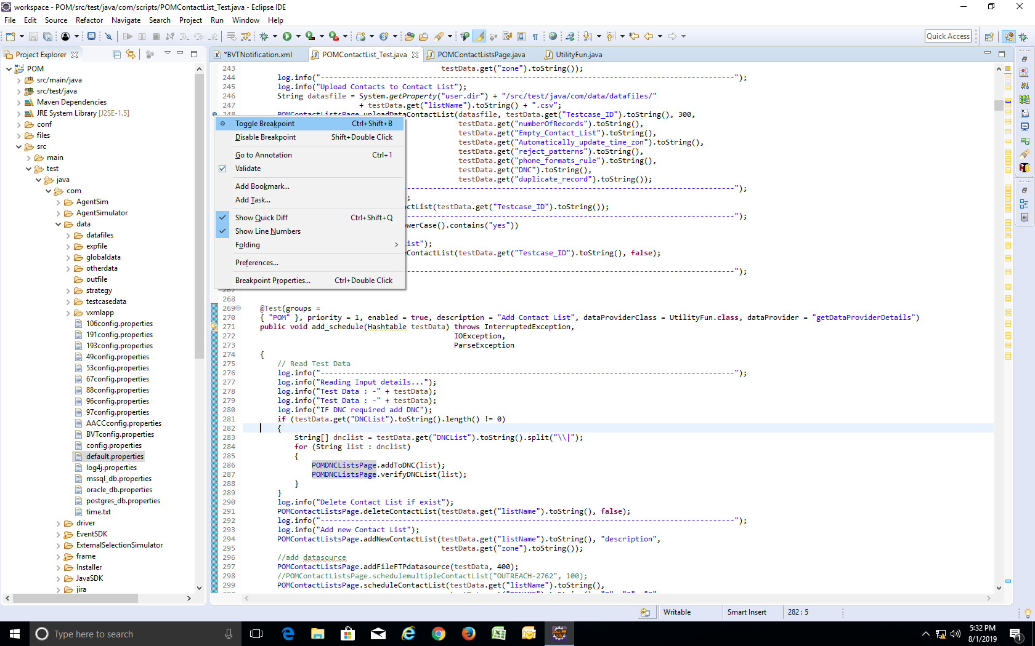 Right click at margin of line that you want to add breakpoint -> choose Toggle Breakpoint

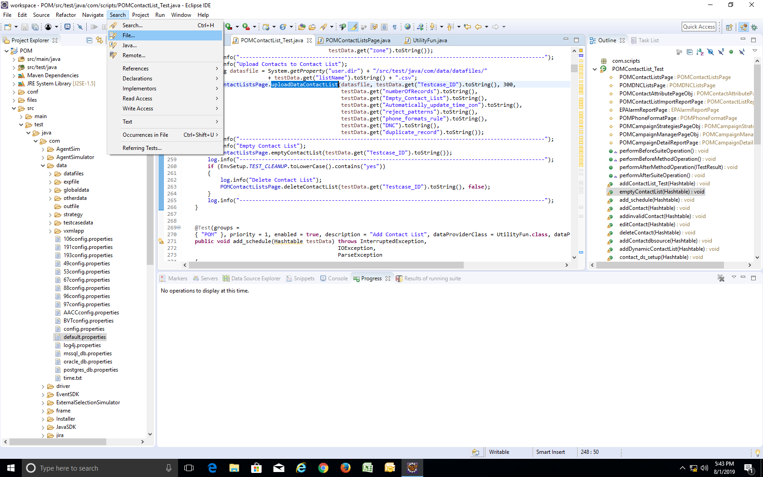**Search File :** use Search File to search on all file in project